

IT3030
Programming Applications and Frameworks
3rd Year, 1st Semester

Practical 4
Report

Submitted to
Sri Lanka Institute of Information Technology

In partial fulfillment of the requirements for the
Bachelor of Science Special Honors Degree in Information Technology

K D K Rangamal
IT23571402
IT WE 01.01
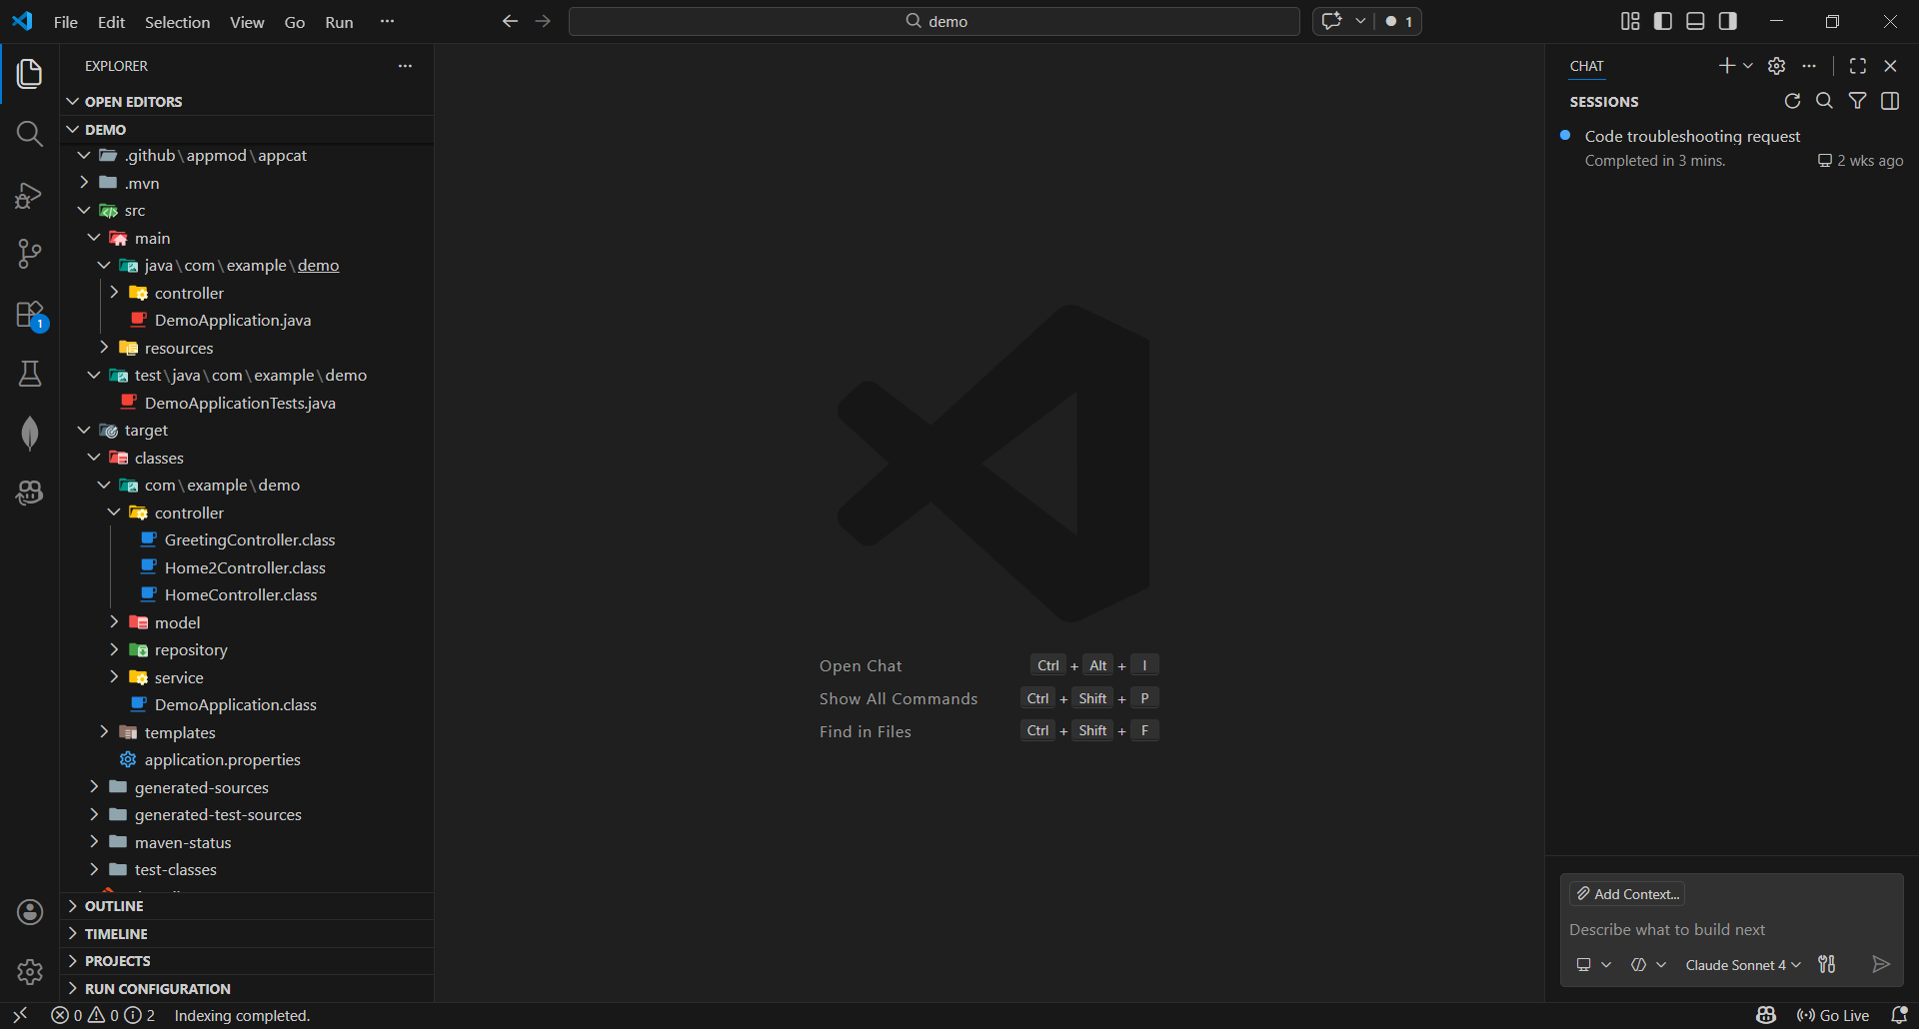

demo\src\main\java\com\example\demo\DemoApplication
package com.example.demo;

import org.springframework.boot.SpringApplication;
import org.springframework.boot.autoconfigure.SpringBootApplication;

@SpringBootApplication
public class DemoApplication {

public static void main(String[] args) {
SpringApplication.run(DemoApplication.class, args);
}
}

demo\src\main\java\com\example\demo\controller\GreetingController.java
package com.example.demo.controller;

import org.springframework.web.bind.annotation.GetMapping;
import org.springframework.web.bind.annotation.PathVariable;
import org.springframework.web.bind.annotation.RequestParam;
import org.springframework.web.bind.annotation.RestController;

@RestController
public class GreetingController {

// 1. Basic greeting endpoint
@GetMapping("/greet")
public String greet() {
return "Welcome to Spring Boot!";
}

// 2. Greeting with path variable and optional query parameter
@GetMapping("/greet/{name}")
public String greetWithName(
@PathVariable String name,
@RequestParam(required = false) String message) {

if (message != null && !message.isEmpty()) {
return "Hello " + name + "! " + message;
} else {
return "Hello " + name + "! Welcome to Spring Boot!";
}
}
}

demo\src\test\java\com\example\demo\DemoApplicationTests.java
package com.example.demo;

import org.junit.jupiter.api.Test;
import org.springframework.boot.test.context.SpringBootTest;

@SpringBootTest
class DemoApplicationTests {

@Test
void contextLoads() {
}

}

demo\target\classes\templates\home.html
<!DOCTYPE html>
<html lang="en" xmlns:th="http://www.thymeleaf.org">
<head>
<meta charset="UTF-8">
<title>Spring Boot Welcome</titl
<!-- Google Font -->
<link href="https://fonts.googleapis.com/css2?family=Poppins:wght@400;600&display=swap" rel="stylesheet">

<style>
* {
margin: 0;
padding: 0;
box-sizing: border-box;
font-family: 'Poppins', sans-serif;
}

body {
height: 100vh;
background: linear-gradient(135deg, #0f2027, #203a43, #2c5364);
display: flex;
justify-content: center;
align-items: center;
overflow: hidden;
}

.card {
background: rgba(255, 255, 255, 0.12);
backdrop-filter: blur(12px);
border-radius: 20px;
padding: 50px 60px;
text-align: center;
box-shadow: 0 0 40px rgba(0, 255, 255, 0.3);
animation: float 4s ease-in-out infinite;
}

@keyframes float {
0% { transform: translateY(0); }
50% { transform: translateY(-15px); }
100% { transform: translateY(0); }
}

h1 {
font-size: 2.5rem;
color: #00ffff;
text-shadow: 0 0 10px #00ffff;
margin-bottom: 15px;
}

p {
color: #ffffff;
font-size: 1.1rem;
margin-bottom: 30px;
}

button {
padding: 12px 30px;
border: none;
border-radius: 30px;
background: linear-gradient(45deg, #00ffff, #00ff88);
color: #000;
font-size: 16px;
font-weight: 600;
cursor: pointer;
transition: 0.3s;
box-shadow: 0 0 15px #00ffff;
margin: 5px;
}

button:hover {
transform: scale(1.1);
box-shadow: 0 0 30px #00ffff;
}

/* animated circles */
.circle {
position: absolute;
border-radius: 50%;
filter: blur(80px);
opacity: 0.7;
animation: move 12s linear infinite alternate;
}

.c1 {
width: 250px;
height: 250px;
background: #00ffff;
top: 10%;
left: 10%;
}

.c2 {
width: 300px;
height: 300px;
background: #00ff88;
bottom: 10%;
right: 15%;
}

@keyframes move {
from { transform: translateY(0); }
to { transform: translateY(-80px); }
}
</style>
</head>
<body>

<div class="circle c1"></div>
<div class="circle c2"></div>

<div class="card">
<h1>Hello John! 👋</h1>
<p>Welcome to Spring Boot!</p>

<!-- Call Greeting REST endpoint -->
<button onclick="window.open('/greet/John?message=Good to see you!', '_blank')">
Greet John
</button>

</div>

</body>
</html>

Pom.xml
<?xml version="1.0" encoding="UTF-8"?>
<project xmlns="http://maven.apache.org/POM/4.0.0"
xmlns:xsi="http://www.w3.org/2001/XMLSchema-instance"
xsi:schemaLocation="http://maven.apache.org/POM/4.0.0
https://maven.apache.org/xsd/maven-4.0.0.xsd">

<modelVersion>4.0.0</modelVersion>

<parent>
<groupId>org.springframework.boot</groupId>
<artifactId>spring-boot-starter-parent</artifactId>
<version>3.2.2</version>
<relativePath/>
</parent>

<groupId>com.example</groupId>
<artifactId>demo</artifactId>
<version>0.0.1-SNAPSHOT</version>
<name>demo</name>
<description>Spring Boot + MongoDB Project</description>

<properties>
<java.version>17</java.version>
</properties>

<dependencies>

<!-- Spring Boot Web -->
<dependency>
<groupId>org.springframework.boot</groupId>
<artifactId>spring-boot-starter-web</artifactId>
</dependency>

<!-- Spring Boot Thymeleaf -->
<dependency>
<groupId>org.springframework.boot</groupId>
<artifactId>spring-boot-starter-thymeleaf</artifactId>
</dependency>

<!-- Spring Boot Data MongoDB -->
<dependency>
<groupId>org.springframework.boot</groupId>
<artifactId>spring-boot-starter-data-mongodb</artifactId>
</dependency>

<!-- Spring Boot Validation (optional but recommended) -->
<dependency>
<groupId>org.springframework.boot</groupId>
<artifactId>spring-boot-starter-validation</artifactId>
</dependency>

<!-- Spring Boot Testing -->
<dependency>
<groupId>org.springframework.boot</groupId>
<artifactId>spring-boot-starter-test</artifactId>
<scope>test</scope>
</dependency>

</dependencies>

<build>
<plugins>

<!-- Compiler Plugin -->
<plugin>
<groupId>org.apache.maven.plugins</groupId>
<artifactId>maven-compiler-plugin</artifactId>
<version>3.12.1</version>
<configuration>
<source>${java.version}</source>
<target>${java.version}</target>
<compilerArgs>
<arg>-parameters</arg>
</compilerArgs>
</configuration>
</plugin>

<!-- Spring Boot Maven Plugin -->
<plugin>
<groupId>org.springframework.boot</groupId>
<artifactId>spring-boot-maven-plugin</artifactId>
</plugin>

</plugins>
</build>

</project>

Out Put

